Checklist High pressure

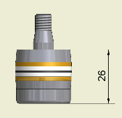
Start an experiment
- Check if the rings on the plunger are new, if not change the rings.

- Put your sample in the machine and use the small dummies to make sure
that your sample will stay vertically. Make sure that you place your vial with the screwcap to the top
- Fill the barrel with pet-ether and put the plunger in the barrel. Remove the spilled pet-ether with a tissue so you can clearly see when the plunger is going down if there is a leak
- Press mode for SP1 and alter the pressure, there is a list with the P1 values and the amount of pressure it stands for. Make sure you change the pressure accordingly to the barrel, if the diameter of the barrel changes the list should be updated!

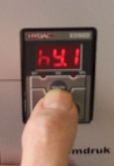
- Press mode twice to see hY1 this value should be 10

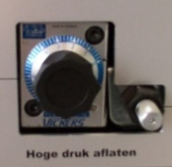
- Check to see if drainage control valve "High-pressure venting" is completely closed (turning knob must point "0").

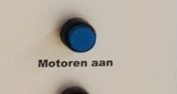
- Turn on the pump by pressing the “motoren aan” button

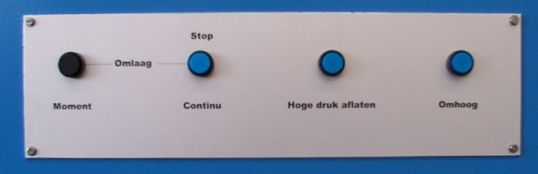
- Now the piston can be lowered by pressing “omlaag continu” until a few centimeters above the plunger and press “omlaag continu” to stop the piston from lowering. Now use the “omlaag moment” to lower the piston further, do this step wise until the piston reaches the top ring of the plunger. Now you can use the “omlaag continu” button again so that the machine will go the pressure you set in step 4.
IF you see that there is solvent coming out of the barrel while the plunger is going into the barrel stop the experiment and check the rings on the plunger probably there is leak so check with Thijs the plunger. (We see always a bit of pet-ether coming out but when the sp1 value is above 16 there shouldn’t be more solvent coming out of the barrel. If it does you stop the experiment.
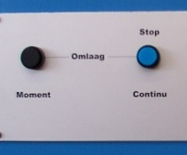
Stop an experiment
- Press the “omlaag continu/Stop” button

- Press the “motoren aan” button to stop the pump

- Press the “hoge druk aflaten” button so that the system can depressurize

- Slowly turn the drainage to depressurize the system, you can start a value of ~2,5-3.5. If the sp1 value is below 80 you can switch it to 4.5 and if it is below the 48 you can open it till ~7.5. Make sure the value of sp1 is 0/4/6 before you are going to manually bring the piston up

- When you have reached sp 0/4/6, you should already see the plunger on the top of the barrel and then it is safe to bring the piston up. If you don’t see the plunger on the top of the barrel something is not right, check with Mathilde/Thijs what seems to be the problem. To get the You do this by pressing “motoren aan” followed by “omhoog”. Sometimes it takes some time before the piston is really coming up, this is normal. Most of the time not all the pressure is released in the barrel so bring the piston up while the plunger is still in the gap of the piston. Wait for 10 seconds, you can observe some leaking of pet-ether or hear a “plop” meaning that the pressure is released. Now bring the piston in the most upwards position by pressing “omhoog” (except if you are using it directly afterwards again).

- Remove the plunger out of the machine by making use of the screw and bahco.

- Remove your sample out of the machine with the hook.

- Replace the rings on the plunger by making use of the old train track and a hammer with a soft head.

- Turn off the heating if you used it.

